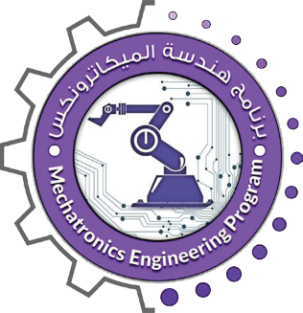
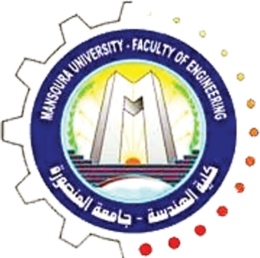

Mechatronics Engineering (MTE) Program
Faculty of Engineering Mansoura University

Project 1
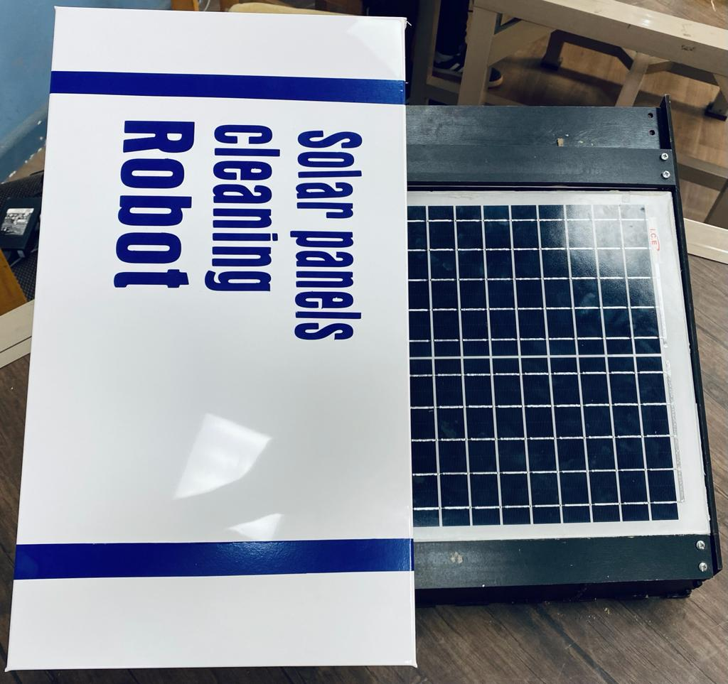
Autonomous Solar Panels Cleaning Robot

Team Members:
Mohamed Alaaeldin Gaafar | Mohamed Hassan Sherif
Mohamed Hataba | Ahmed Sherif Salem ElSayed
Mustafa Elsherbiny | Abdelrahman Ahmed Mostafa
Abdallah Emad Elhussini | Hany Samir Abdellatif Atia
Kareem Abdelnasser Mohamed

Supervision of:
Dr. Fatma Elerian
Eng. Mohamed Soleiman
2022

